Dear Paschal Alumni Golfer:

Please join us for the 27th annual Paschal Alumni tournament being held again this year at the Split Rail Golf Club in Aledo.

The tournament will be on Friday, June 3rd, 2016 with a 1:00 p.m. shotgun start. The entry fee is $95.00 per player and $70.00 for a hole sponsorship. The entry fee includes golf, cart, range balls, and lunch will be provided. Registration will open at 11:30 a.m. and lunch will be served at that time.

Please return your registration form and payment to The Alumni Association by May 26th as there are a limited number of playing spots.

If you have any questions or need further information, please feel free to call me @ 817-235-1878 or email @ rmotheral56@gmail.com. You may also contact Peter Hinojosa @ 817-239-0055 or email @ pchinojosa@sbcglobal.net. We look forward to seeing you there.

Sincerely,
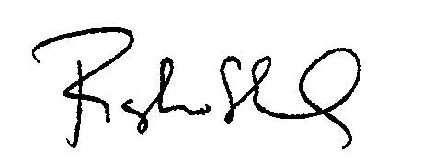

Roger Motheral

Split Rail Golf Club
2151 Old Annetta Rd.
Aledo, Texas 76008
817-441-4653

(Detach and mail to the Paschal Alumni Association @ P.O. Box 11876, Ft. Worth, Texas 76110-0876)

PHS Alumni Golf Tournament Registration Form

Name:_____________________________________ No. of Players: _____@ $95 = $________
Address: ___________________________________Hole Sponsor: _____@ $70 = $________
City/St/Zip:__________________________________________ Total Enclosed: $________
Cell Phone:_______________________________ E-mail:______________________________
Team Members: ________________________________________________________________
Handicap: _______________Class Year: ______________

